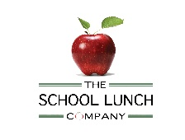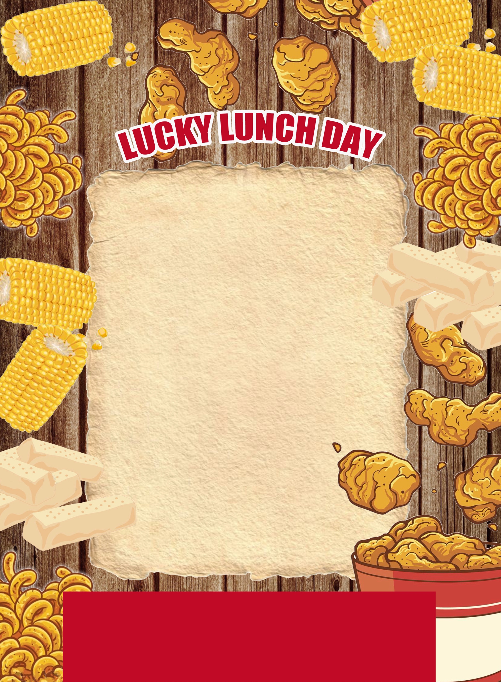

**Thursday 20th**

**January 2022**

**Breaded Chicken Fillet Poppers**

**Or**

**Southern Style Quorn Burger**

**Curly Fries**

**Peas and Sweetcorn**

**Colonels Geering Gravy**

**Chocolate Shortbread**

Charlton-on-Otmoor Primary

Will you be the winner of our winning plate competition?

One lucky person will win a prize if you have the winning stickered prize plate.

Of course, you must finish your lunch before you can check!